Agriculture Assignment
- Go to http://www.agribusinessonline.com/stats/
  - Click on Statistics on the left side of the page. Here you will find U.S. imports of agricultural products for consumption in both dollars and quantity. Use either dollars or quantity to provide your data.
  - Click on the HTS Code for several products. Find at least 5 products in which U.S. demand has decreased consistently from 1996 to 2002. List the 5 products and the country from which it comes.
  - Click on the HTS Code for several products. Find at least 5 products in which U.S. demand has increased consistently from 1996 to 2002. List the 5 products and the country from which it comes.
  - Make notations for at least countries on each product chart which may be decreasing while another country is increasing imports of the same product.
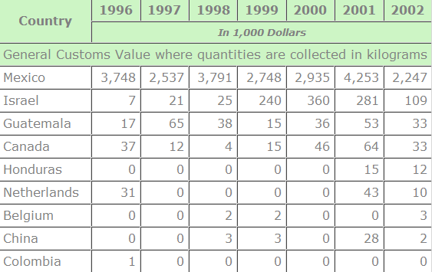
Figure 1: Example of Chart
- Choose 3 products which have decreased in imports to the U.S. Make 3 separate product maps and indicate each country with a different color.
- Choose 3 products which have increased in imports to the U.S. Make 3 separate product maps and indicate each country with a different color.
- Using the data you have retrieved and mapped, discuss possible reasons why demand has increased for the products you researched. Be sure to discuss dietary changes, special issues, transportation costs, climate, weather events or other reasons (500 words).

